Research Document
AI Tool: Converting APIs to MCPs

Date of Submission: 06/11/2026
Supervisor: Paul Barry



Amelia Hamulewicz
C00296605

Table of Contents
MCP Tool Definitions: 3
Mapping API Descriptions to MCP Tools: 4
Get Product by ID Example 4
Update Product Example 5
Parsing the OpenAPI JSON File 6
Tool Definitions 6
Name, Title and Description 6
Input Schema 7
Output Schema 10
References 11

MCP Tool Definitions:
During my research, I found that an MCP tool definition contains required and optional fields. These can be populated using information from an OpenAPI description:

- name: Unique identifier for the tool {required}
- title: Human-readable name of the tool for display purposes. {optional}
- description: Human-readable description of functionality {optional}
- inputSchema: JSON Schema defining expected parameters {required}
- outputSchema: JSON Schema defining expected output structure {optional}
- annotations: Properties describing tool behaviour {optional}

[1,2]

Here is a weather tool example I found on the MCP documentation:

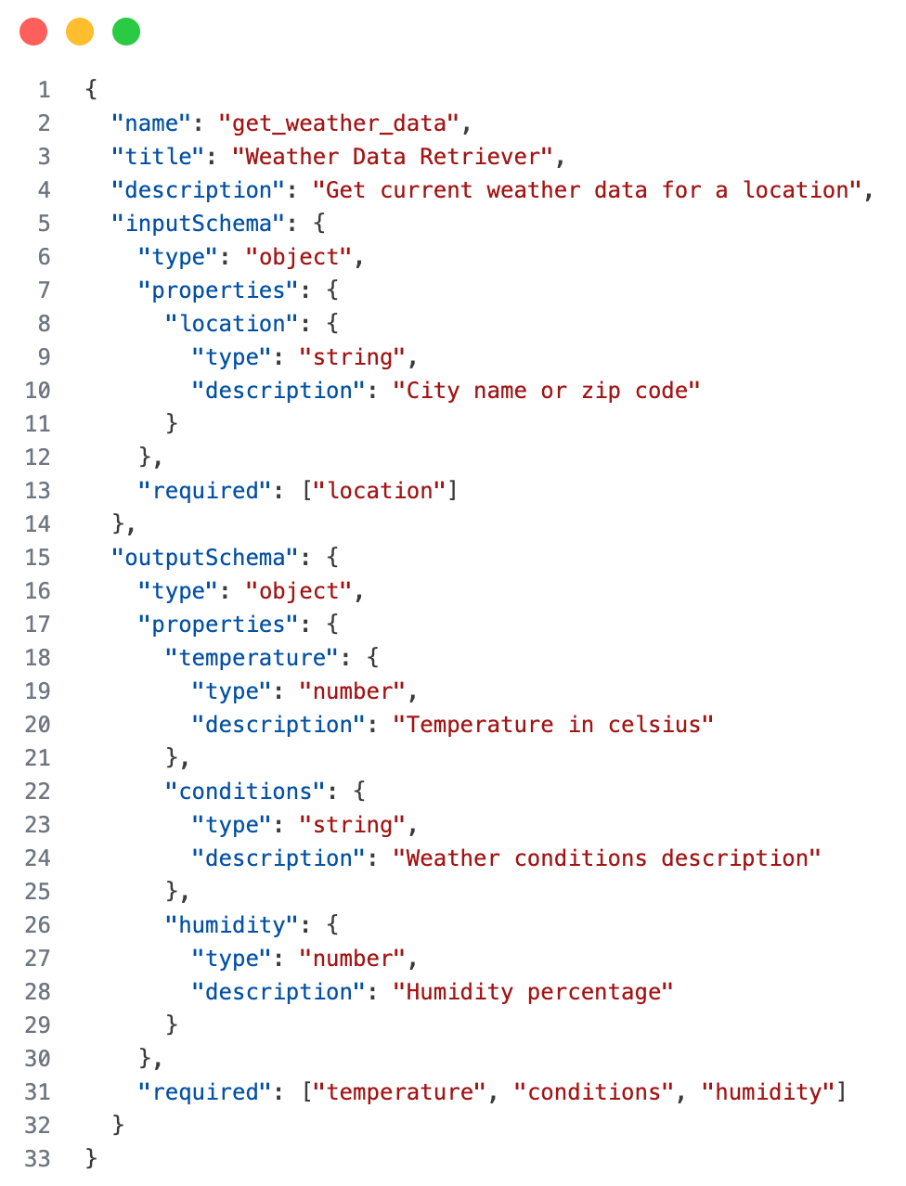

[Figure 1: Example of an MCP tool definition (Source: [1]) ]

Mapping API Descriptions to MCP Tools:
Now that we understand the tool definition, we can map our API description in JSON format to an MCP tool.
The Get Product by ID example below shows how the API fields map to the tool definition:

Get Product by ID Example
In this example, no summary or description is provided, so we use the operationId as a fallback for the tool’s description.

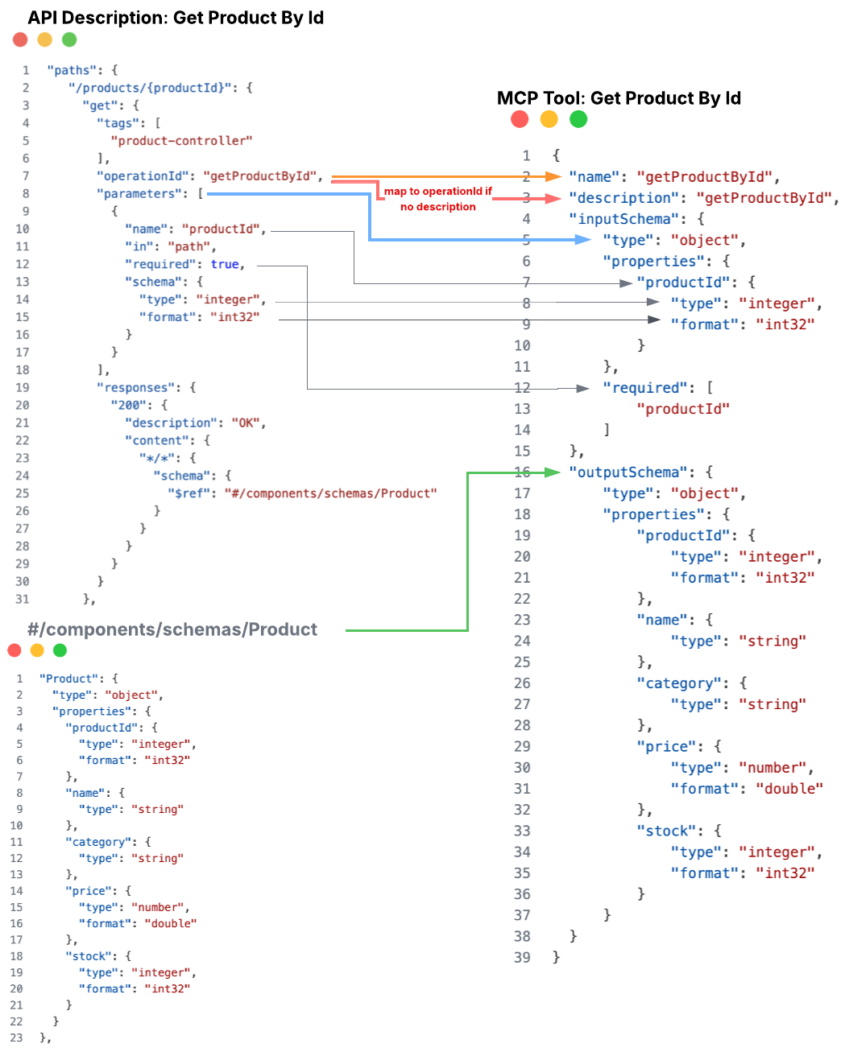

[Figure 2: Get Product by ID Example (Source: Author)]

Update Product Example
In this example, the API provides a summary and description, which we use as the tool’s title and description. No response schema is provided, so the tool does not include an outputSchema.
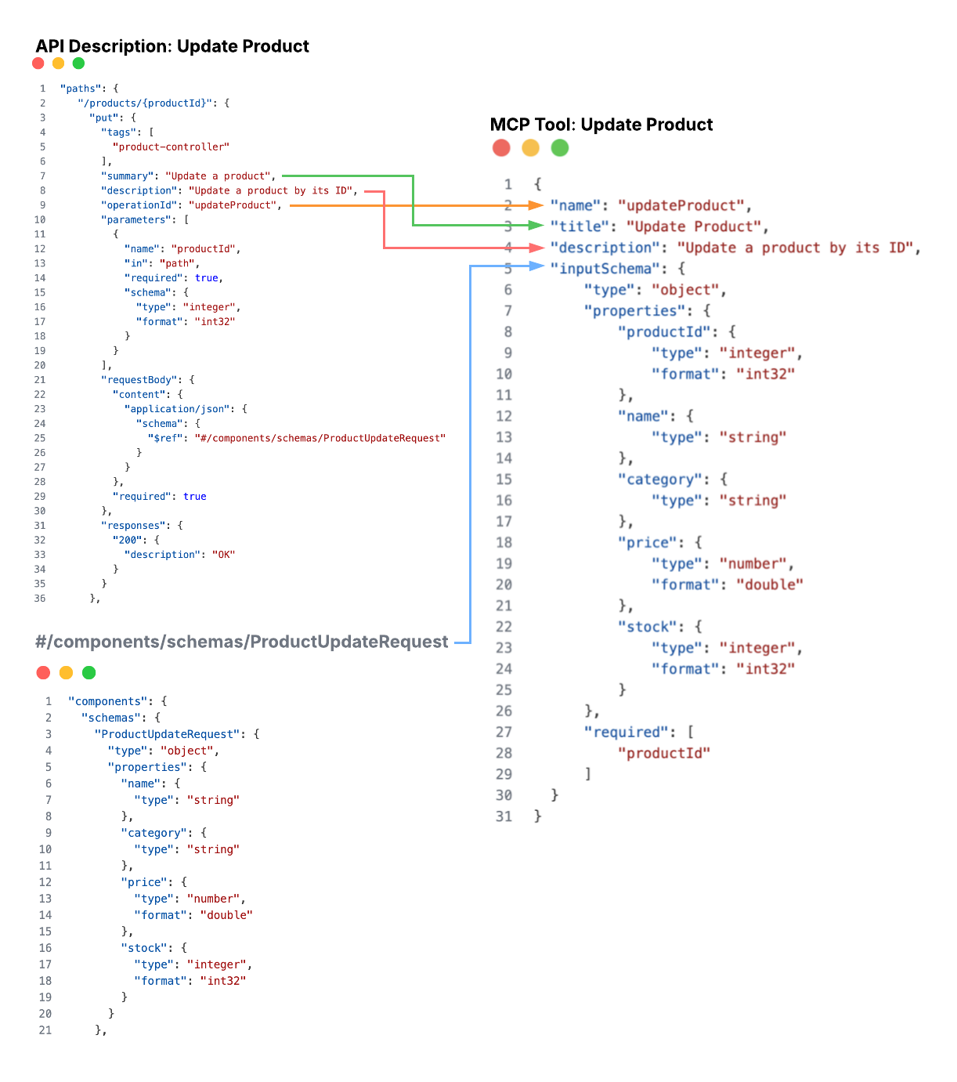

[Figure 3: Update Product Example (Source: Author)]

Parsing the OpenAPI JSON File
The parser reads the OpenAPI JSON file and goes through it. For each operation, it extracts the information needed to create an MCP Tool Definition.

Tool Definitions
In my code, apiOperations stores:

- Name
- Title
- Description
- Input Schema
- Output Schema
- HTTP method
- Path
- Server URL

I will use the operation examples of updateProduct() and getProductById() to walk you through the parser.

Name, Title and Description
Below you can see how my code grabs and stores the operationId as the tool name, the summary as the title, and the operation description as the tool description. If no description is provided, the code uses the summary instead. If neither is available, it uses the operationId. [3]

parser.py | OpenAPI.json
# Go through each path in the API description  for path in data["paths"]:  # go through each method  for method in data["paths"][path]:  operation = data["paths"][path][method]  # Skip anything that isn't a method  if method not in ["get", "post", "put",  "patch", "delete"]:  continue  # Get the operation description  description = operation.get("description")  if not description:  description =  operation.get("summary")  if not description:  description =  operation["operationId"]  # Store information about operation  operationInfo = {  "name": operation["operationId"],  "title": operation.get("summary"),  "description": description,  // …  } | "paths": {  "/products/{productId}": { // path  "put": { // method  // operation  "tags": [  "product-controller"  ],  // Title = operation[“summary”]  "summary": "Update a product",  // Description = description  "description": "Update a product by its ID",  // Name = operation[“operationId”]  "operationId": "updateProduct”,

Input Schema
The inputSchema defines what inputs an MCP tool expects and which of them are required.
To create this, my parser looks at the parameters and requestBody sections of the OpenAPI file. It extracts the input names, their schemas and whether they are required.
Parameters for updateProduct:
parser.py | OpenAPI.json
#get parameters  parameters = operation.get("parameters", [])  for parameter in parameters:  parameterName = parameter["name"]  # Add parameters to the input schema  inputSchema["properties"][parameterName] = getSchemaDetails(  parameter["schema"]  )  if parameter.get("required", False):  inputSchema["required"].append(parameterName) | "parameters": [  {  "name": "productId",  "in": "path",  "required": true,  "schema": {  "type": "integer",  "format": "int32"  }  }  ],  "requestBody": {  "content": {  "application/json": {  "schema": {  "$ref":"#/components/schemas/ProductUpdateRequest"  }  }  },  "required": true  },

RequestBody for updateProduct:
parser.py | OpenAPI.json
# Check for a request body  requestBody = operation.get("requestBody")  if requestBody:  schema = requestBody["content"]["application/json"]["schema"]  # Get schema details  schemaDetails = getSchemaDetails(schema)  properties = schemaDetails.get("properties", {})  # Get required properties  requiredProperties = schemaDetails.get("required", [])  # Go through body inputs  for propertyName in properties:  # Add request body fields to the input schema  inputSchema["properties"][propertyName] = properties[propertyName]  if propertyName in requiredProperties:  inputSchema["required"].append(propertyName) | "requestBody": {  "content": {  "application/json": {  "schema": {  "$ref": "#/components/schemas/ProductUpdateRequest"  }  }  },  "required": true  },  // . . .  "components": {  "schemas": {  "ProductUpdateRequest": {  "type": "object",  "properties": {  "name": {  "type": "string"  },  "category": {  "type": "string"  },  "price": {  "type": "number",  "format": "double"  },  "stock": {  "type": "integer",  "format": "int32"  }  }  },

The outputSchema result for UpdateProduct:
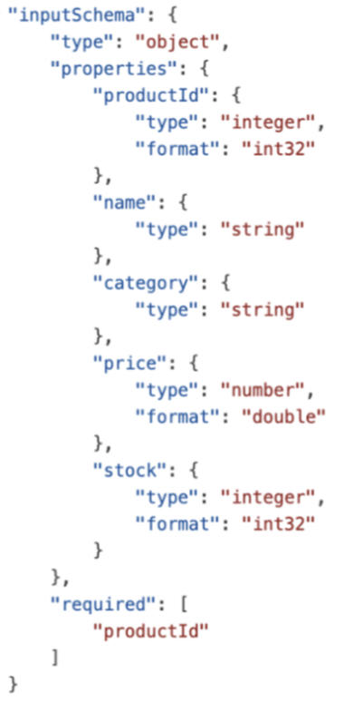

Output Schema
The outputSchema defines the structure that an MCP Tool returns. [4]
To create this, my parser looks at the responses section of the OpenAPI file. It checks for a successful response and retrieves its schema if one is provided.
For example, the getProductById operation returns a product, so the parser uses the response schema to create the MCP tool's outputSchema.
parser.py | OpenAPI.json
# Check for a successful response  responses = operation.get("responses", {})  for statusCode in responses:  if str(statusCode).startswith("2"):  response = responses[statusCode]  content = response.get("content", {})  if content:  mediaType = next(iter(content))  schema = content[mediaType].get("schema")  if schema:  # Get schema details  schemaDetails = getSchemaDetails(schema)  # MCP outputSchema must describe an object  if schemaDetails.get("type") == "object":  operationInfo["outputSchema"] = schemaDetails  elif schemaDetails.get("type") == "array":  operationInfo["outputSchema"] = {  "type": "object",  "properties": {  "items": schemaDetails  }  }  else:  operationInfo["outputSchema"] = {  "type": "object",  "properties": {  "result": schemaDetails  }  }  break | "responses": {  "200": {  "description": "OK",  "content": {  "*/*": {  "schema": {  "$ref": "#/components/schemas/Product"  }  }  }  }  }  "Product": {  "type": "object",  "properties": {  "productId": {  "type": "integer",  "format": "int32"  },  "name": {  "type": "string"  },  "category": {  "type": "string"  },  "price": {  "type": "number",  "format": "double"  },  "stock": {  "type": "integer",  "format": "int32"  }  }  },

References
[1] Model Context Protocol. (2025). Tools – Data Types. Available at: https://modelcontextprotocol.io/specification/2025-06-18/server/tools#data-types
[2] Model Context Protocol. (2025). Schema Reference – Tool. Available at: https://modelcontextprotocol.io/specification/2025-06-18/schema#tool
[3] Scalar. (n.d.). REST API to MCP Server – Naming and Describing Tools. Available at: https://scalar.com/learn/mcp/rest-api-to-mcp-server#naming-and-describing-tools
[4] Model Context Protocol. (2025). Tools – Output Schema. Available at: https://modelcontextprotocol.io/specification/2025-06-18/server/tools#output-schema

